Test Generation Tools

## Mockaroo

Explore <https://www.mockaroo.com/help/scenarios>

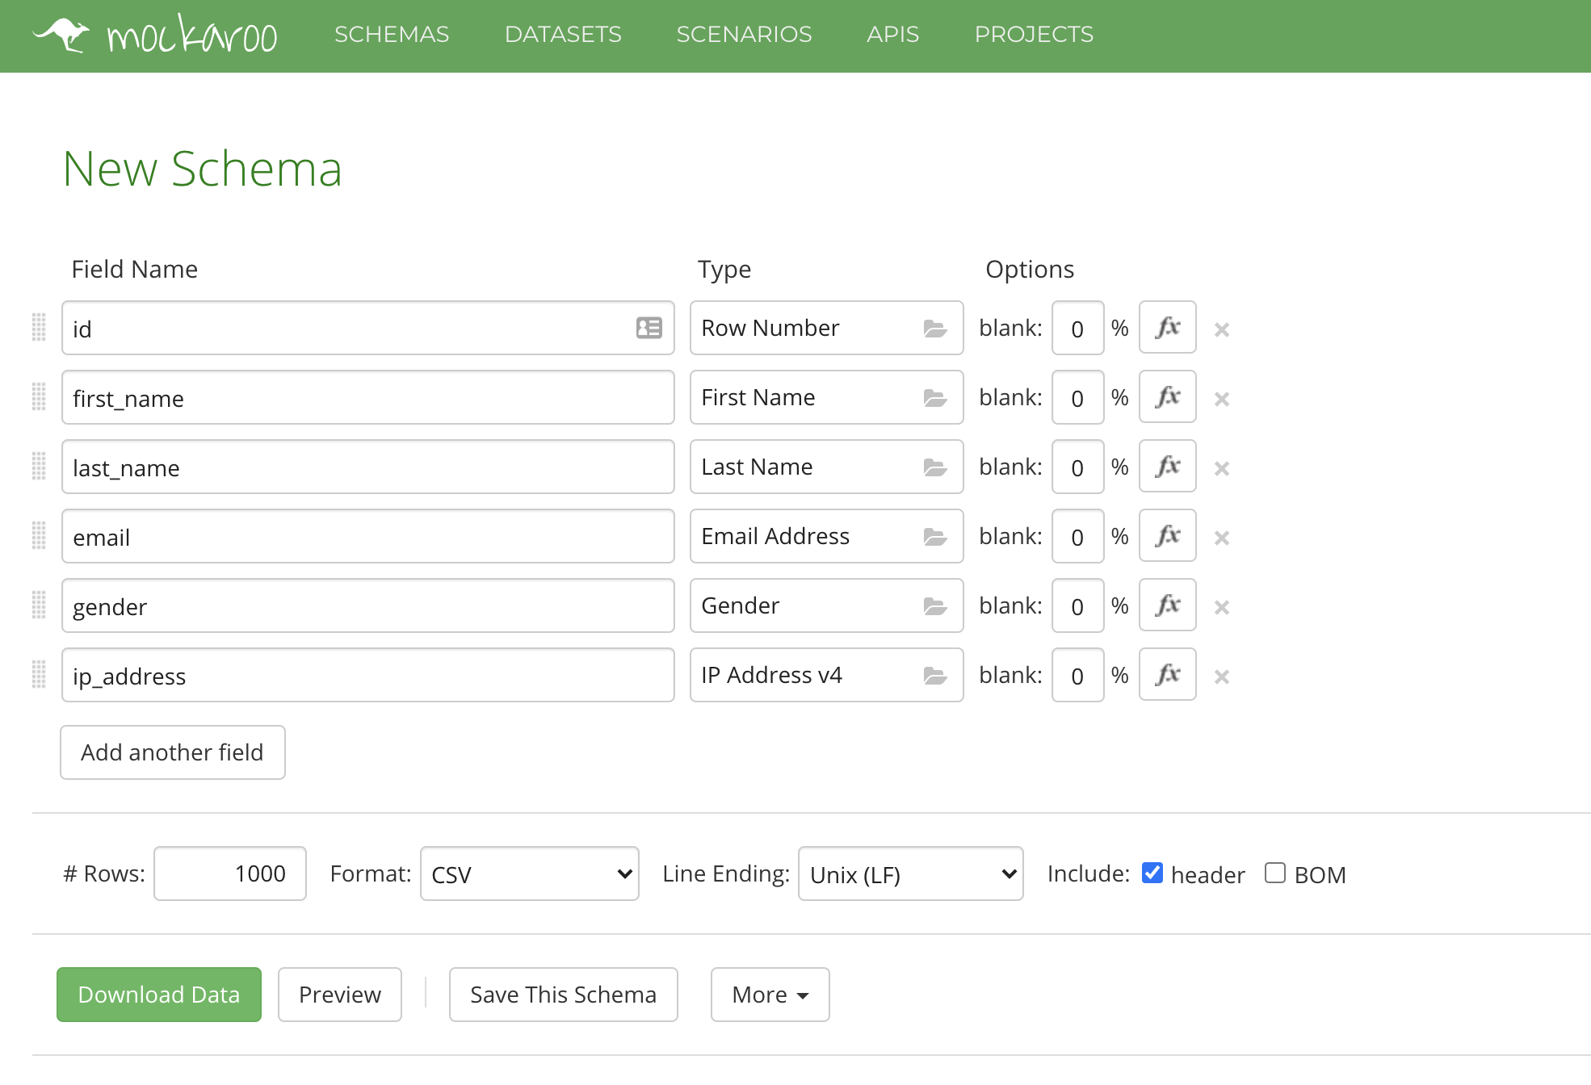

## Generate Data

Explore <https://generatedata.com/>

Output in json format, csv format

